Storyboard sample

This is a basic sample of the type of document we use for some of our storyboards. You might want to include some additional items in the storyboard, depending on the complexity of your eLearning project.

Enjoy!

Latest revision: dd/mm/yyyy
Revised by:

Course title: Insert your title here
Course length: XX minutes
Learning Management System: Insert relevant information here
Modules: Insert number of modules and their titles
Course description: This is where you can provide a short description of the course

Project manager: This is where you can name people who will be managing the project
Developer: This is where you can name who is responsible for developing the course
Other responsibilities: You can also name other involved persons, such as subject matter experts, design specialists etc.

Detailed storyboard

Title | Insert your title here
Text | This is where you insert the text that will be shown on the page. Don’t forget to format the text properly – split the text into paragraphs, use bold/italic formatting thoughtfully.  If you want some of the text to be numbered or bulleted, make sure to indicate that as well.
Secondary text | This is where you can add additional text that can be revealed (for example, by clicking a button or selecting a tab).
Layout | 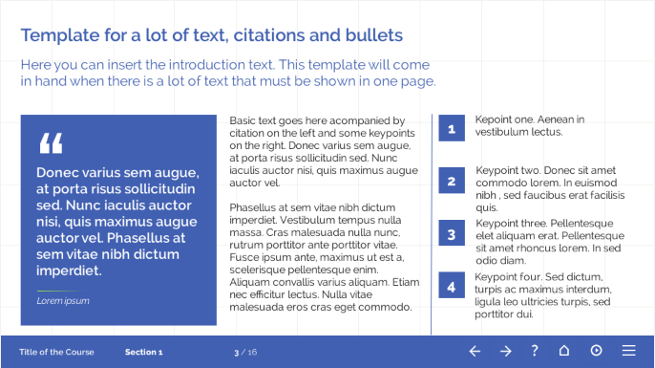  This is where you can provide information about the page layout. Ideally, you could provide a sketch or a screenshot like the one above.
Media | This is where you indicate what image/video/audio material you want to include on the page and where it can be obtained.
Functionality | This section deals with the technical aspects of the page. You may want to include information about all interactions on the page, such as navigation and how clickable objects will work.
Additional notes | You can use this space to add some specific notes that refer to this page.

Usage Instructions: Copy this page for each page in the course

